(C)

- AT THE END OF THE WORLD –

Shooting script for a short (anti)-war film
by
Nikola Vrbavac
based on the Genesis song »One For the Vine«
by Tony Banks
& Aleister Crowley's (Khaled Khan's)
(C)
»The Heart of the Master«

1.
0. INT. – THE SISTINE CHAPELL, VATICAN – DAY

- DETAIL (OF RIGHT HAND), TRACKING SHOT BACKWARDS, FULL VIEW

Michelangelo Buanaroti: »Last Judgment«

Music: Tchaikowsky's piano concerto No.1

Titles of the film's Talents & Cast

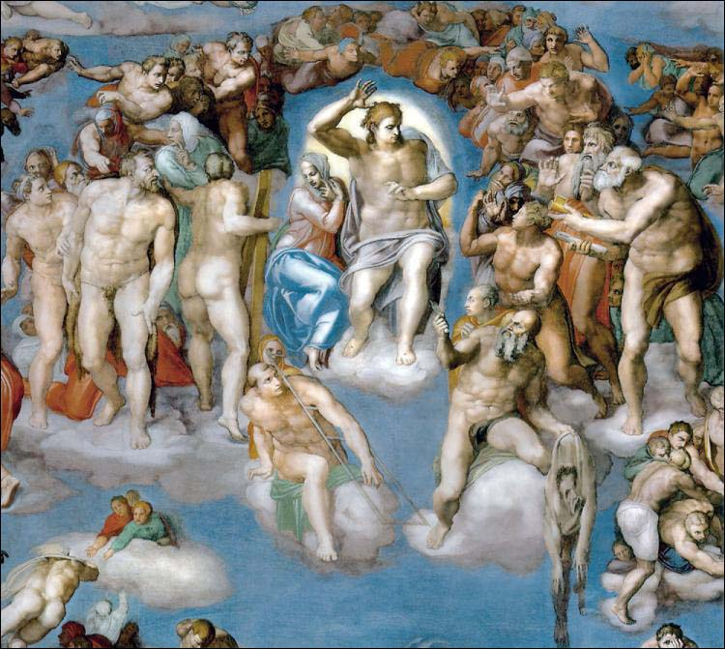

CONTINUED:

2.
1. THE LAST JUDGMENT

Michelangelo Buonaroti: »The Last Judgment« (1536-1541)…

The vision backs up from Christ's raised right hand, revealing all the majestical solemnity and the mighty calmness of the redeemer's figure, at this (long prophesed and expected) historical act at the end of the Biblical (and Mayan) civilization in the year 2012 A.D. (Era Vulgari).

Accompanying music: Tchaikowsky: Piano concerto No.1…

INSCRIPTION:

Based on Genesis song »One For the Vine« by Tony Banks

& Aleister Crowley's: »The Heart of the Master«

A FILM BY
o
NIKOLA VRBAVAC ( Therion Aries-Libra XI )

- AT THE END OF THE WORLD –

Even the forces of Heaven seem surprised and perplexed concerning the stillness and divine superiority by which the Messiah leads the greatest army of Saints in history into Agrameddon, the final battle between the forces of light and darkness, which ends in Termidor for the forces of hell.
Minos, the king of hell and his demons, are persuasively sent down into the depths of hell.
Charon forces the demons on his bark, where they tumble over each other in confusion on the way to the jaws of the abyss.
Minos, the Vatican administrator, who proclaimed Michelangelo's frescos unworthy of the holy walls, is cought into the iron strangulation of the Serpent.

3.

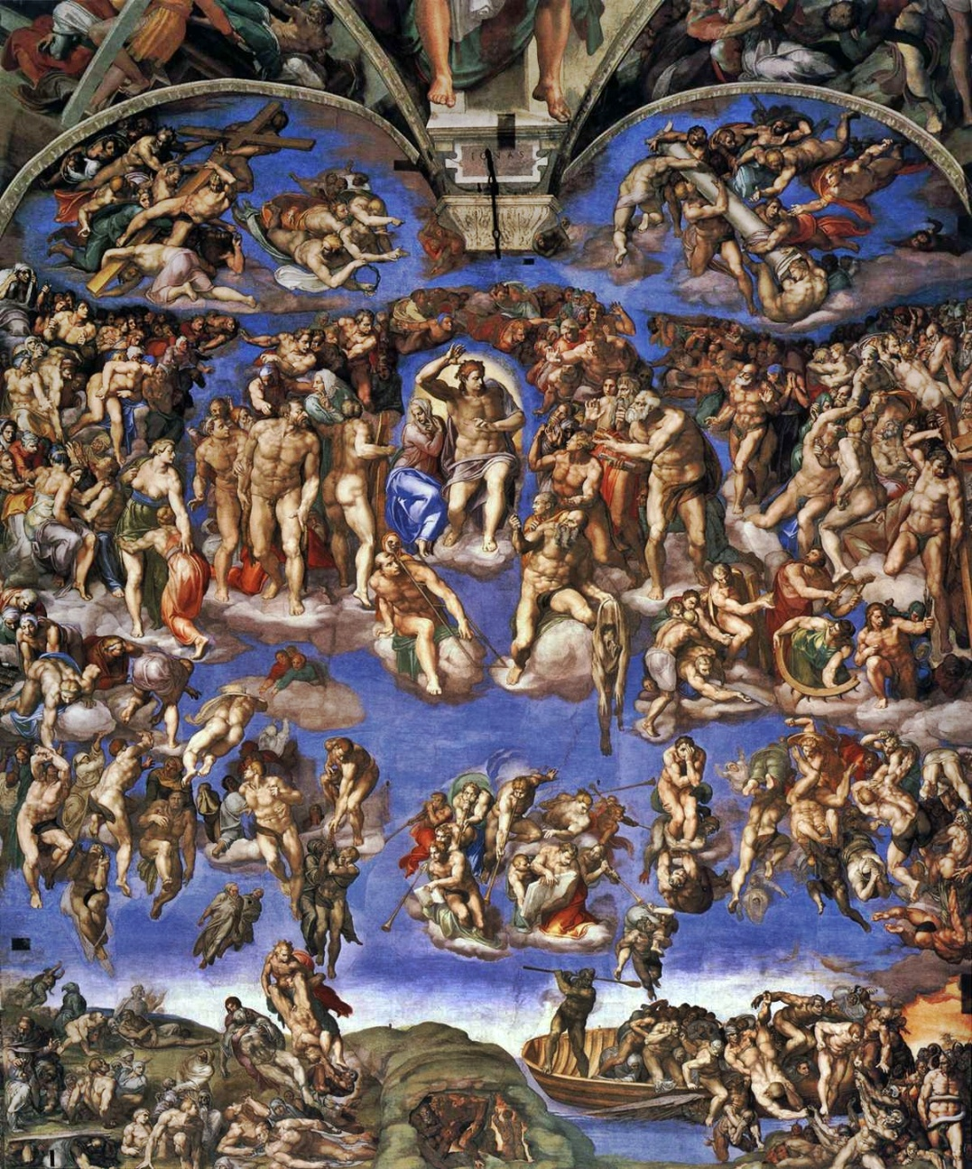

LAP DISSOLVE :
CONTINUED:
4.
2. EXT – THE SKY ABOVE - MORNING

- FULL VIEW, HELICOPTER SHOT FORWARDS

»Heavens«. The vision is flying through white, but fairly dense clouds – cumulus in the crystally blue sky. They are lit by the shining glow of the morning Sun...

INSCRIPTION:

Dedicated to Vilko Filač (1950-2008)

In vain it did not pass away,
Not the good,
Nor the evil,
It all glowed brightly,
But all of it – so little !
Arsenij Tarkovsky

INSCRIPTION LAP DISSOLVE:

- EXT – BEFORE THE PREDJAMA CASTLE – FOGGY MORNING

- FULL VIEW, DOLLY CRANE SHOT DOWNWARDS, MEDIUM FULL VIEW

INSCRIPTION:

In an unknown country not in the East, nor in the West, the year 2012 E.V.,
at the end of the Biblical and Mayan time

INSCRIPTION FADE OUT:

Under the sky, a world attraction, the magnificent Predjama Castle wrapt in the morning fog. A military base where two GUARDS are standing erect before the entrance.
(The opening scene's musical backgound is Popol Vuh's »Ah !« from Hosianna Mantra album...)

5.

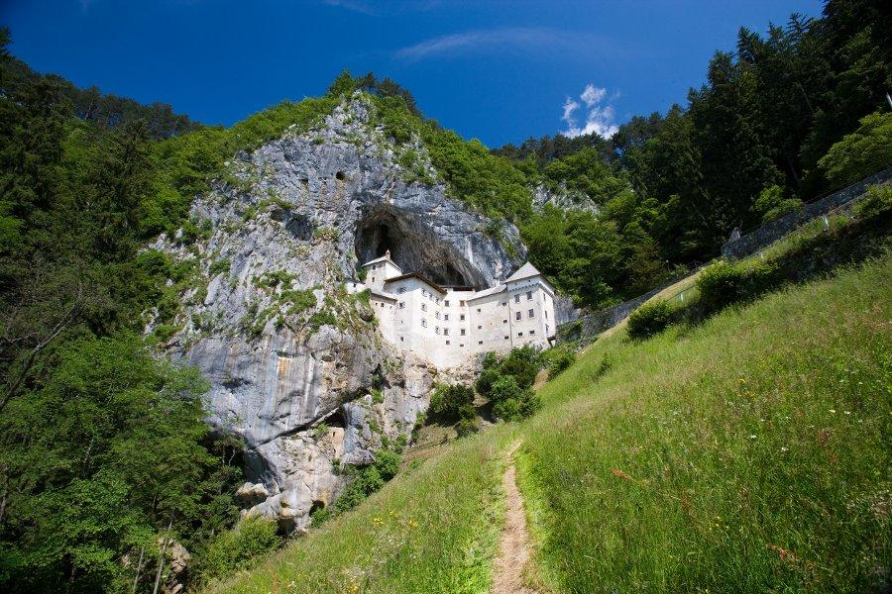

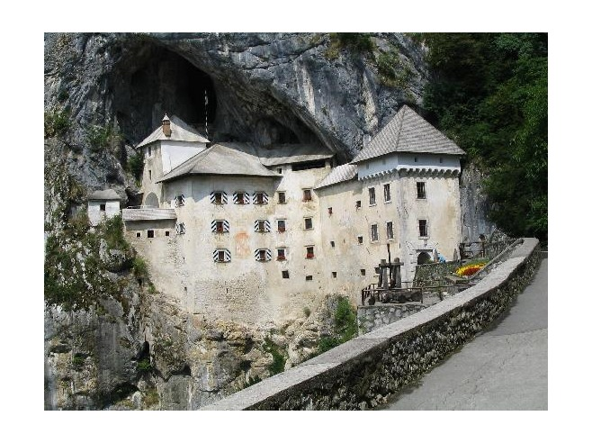
A platoon of SOLDIERS is marching out of the casle build-within-a rock. They are led by the CAPTAIN on a white horse.
CONTINUED:
6.
They are dressed like a modern army, well armed, with moterolas and all necessary equipment.
But on their faces one can see that they seem exhausted, except for the CAPTAIN in his long officer's overcoat, who does not hide his slightly sardonic and sadistic smile, proud of his leadership. But when he turns around, he sees the unsatisfied faces of his men.
At the end of the column, DAMIEN and his fellow soldier, the equally disillusioned ANTHONY, march in silence...

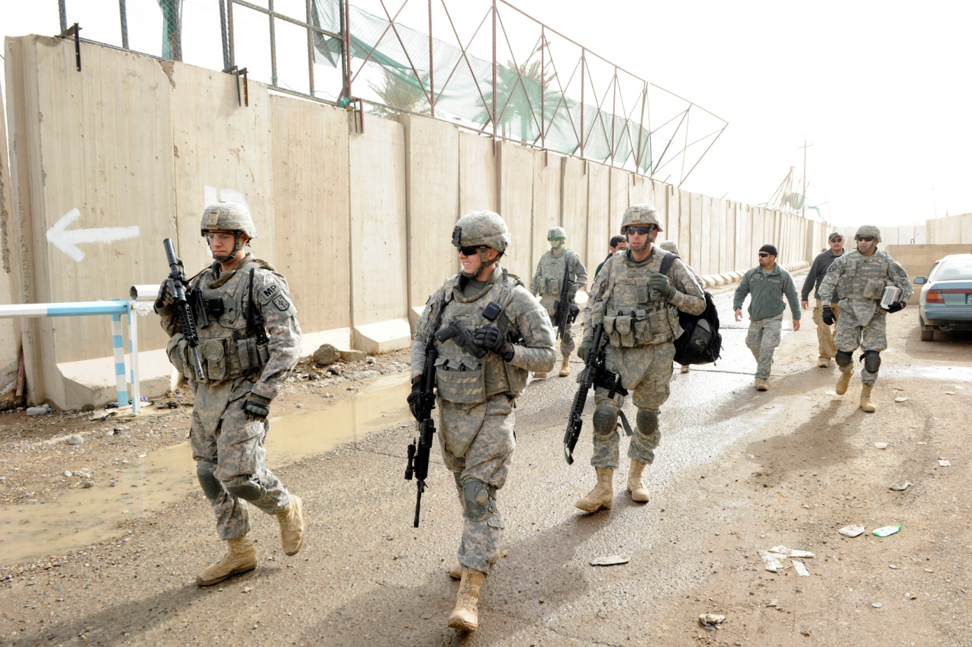

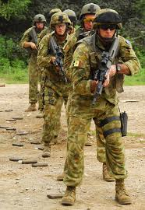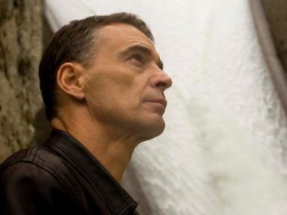

CONTINUED:

7.

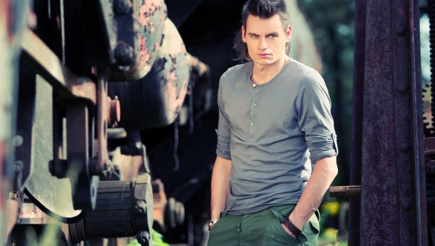

- AMERICAN, TRACKING SHOT BACKWARDS, CLOSE-UP

On DAMIEN'S and ANTHONY'S face we can see that they are both unsatisfied by their position...

DAMIEN
(off)
I am one of the concourse. Dazed, stupefied –
I know not who I am – I know not whence I came -
I know not wither I go. All, or nigh all, seem
fallen into heaviness, not from exhaustion of
labour, but from lethargy.

DAMIEN
I am sure of this: that all discipline is done, all courage
quashed, all purpose perished. I know now that I am
one of a great army-an army baffled and broken, but
yet in being...

ANTHONY
Sharp comes the swift absolute authority, my friend.

LAP DISSOLVE:
- EXT – A PLAIN – SUNSET, EVENING
4.FULL VIEW
The CAPTAIN gives the order, and the SOLDIERS stop upon a plain to rest...

CONTINUED:
8.

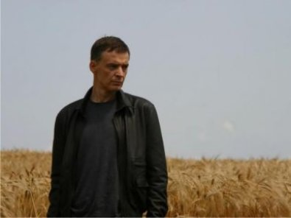

- CLOSE VIEW

CAPTAIN
We stop here, ladies ! Make camp for the night !
o
- CLOSE VIEW, PAN SHOT RIGHT 180

The plain seems to be on the top of the world, or on another planet...

DAMIEN
(off)
The plain is vast beyond eye to mark its bounds,
even were not all dark with blight of fog and thick
with marish damp.

The SOLDIERS unpack and prepare the bivouac.

- MEDIUM VIEW

DAMIEN makes camp and rests on the ground, and opens a can of food from his rucksack.

DAMIEN
(off)
A few of us are half awake, gaze dumbly on the East.
No light responds

CAPTAIN
Behold, the Star in the West !

Instant on that comes silence.

CONTINUED:
9.
DAMIEN
(off)
That is no voice of any leader of ours...

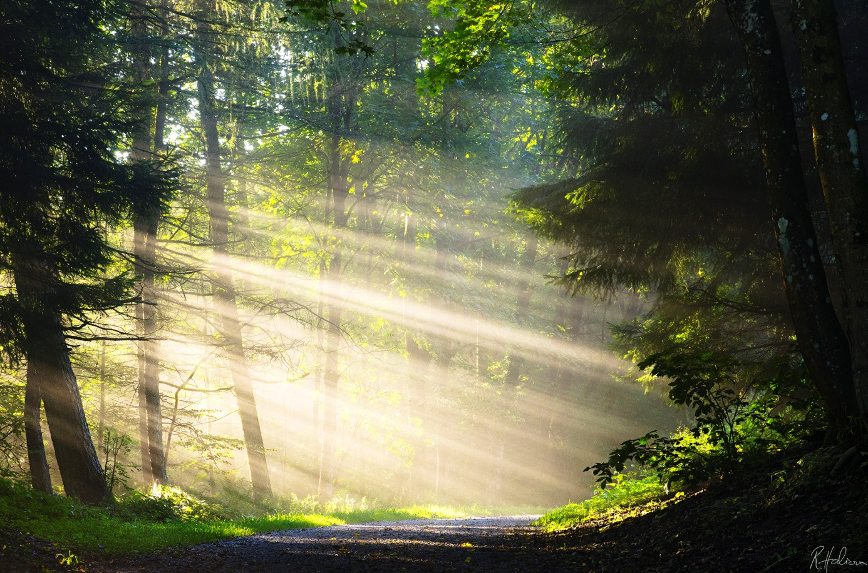

- MEDIUM FULL VIEW

The SOLDIERS are gathered around a camp-fire eating their cans of food. ANTHONY is playing the diactonic harmonic: »The International«...

- CLOSE-UP

DAMIEN stares at the Sun setting behind clouds...

DAMIEN
(off)
. But among us the sudden stirring warns me that not
All were sleeping; that there were watchers like myself,
Men more intent than I.

He hears a murmur on his left, and catches three words...

SOLDIER 1
The Zero Hour...

Sharp comes a whisper of swift absolute authority...
CONTINUED:
10.
SOLDIER 2
Zero is two...

10. MEDIUM CLOSE VIEW

SOLDIER 3
The hour approaches, when he will strike...

SOLDIER 1
D-day...

11.CLOSE-UP

SOLDIER 2
Sixth, sixth at six o'clock...

12.CLOSE (TELEPHOTO)

The molten orb of glory can hardly be seen from the clouds in the West...

13.DETAIL, ZOOM BACKWARDS, CLOSE-UP

DAMIEN lights a cigarette...

DAMIEN
(off)
Alas for me who am too much alive with the horrible
ache for sleep of one halfdrugged.

14.MEDIUM CLOSE VIEW

ANTHONY plays his harmonic as if inspired...

15.MEDIUM FULL VIEW, TRACKING SHOT FORWARDS, CLOSE VIEW

The sound echoes into the night...
In the evening, DAMIEN is on the watch...

DAMIEN
(off)
Vaguely I say within my dull heart: I must not sleep
because I am a soldier.

16.FULL VIEW

Everyone has fallen asleep by the camp-fire, except for ANTHONY who is still playing the harmonic...

17.CLOSE VIEW

DAMIEN ponders...
CONTINUED:
11.
DAMIEN
(off)
But of what Captain, in what war ? There is but a
dim shape of some disaster long, oh ! very long ago...

LAP DISSOLVE:

5.EXT – THE VILLAGE OF ŠKOCJAN – MORNING
18.FULL VIEW
Built on the edge of a cliff, is a picturesque small village of Škocjan. This fairy-tale place is built on a rock forming the Škocjan natural labyrinth.
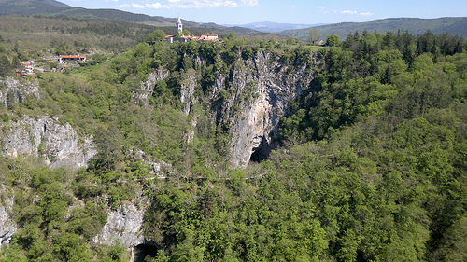
19.MEDIUM FULL VIEW, DIAGONAL TRACKING SHOT BACKWARDS, MEDIUM VIEW
DAMIEN and the other SOLDIERS spread out through the small village...
DAMIEN
(off)
The dusty memory of some leader who
failed, some plan that broke its spine.

20.CLOSE VIEW
Suddenly, the CAPTAIN cries out...

CAPTAIN
Behold ! The enemy sniper on the church tower !

21.LOW ANGLED AMERICAN

A SNIPER appears on the church tower, fireing his gun...
CONTINUED:
12.
22.LOW MEDIUM VIEW

As they duck, DAMIEN hears a shot detonating next to him.

23. MEDIUM CLOSE VIEW

The SHARPSHOOTER shoots again...

24. MEDIUM FULL VIEW

All of a sudden, another gun shot detonates behind DAMIEN, killing a one of the SOLDIERS...

25. CLOSE-UP

SOLDIER 1
For God's sake ! Don't look at that damned light !

26. CLOSE VIEW

SOLDIER 2
We're lost...

27. CLOSE-UP

SOLDIER 3
The Beast ! Maniac ! Antichrist !

28. MEDIUM CLOSE VIEW

The CAPTAIN shoots the SHARPSHOOTER on the church tower,

29. LOW MEDIUM FULL VIEW, TRACKING SHOT FORWARDS & ZOOM BACKWARDS

and he looses balance and falls down into the abyss...

LAP DISSOLVE:

6.EXT – RUINS OF ŠKOCJAN CASTLE – MORNING

30. CLOSE-UP, TRACKING SHOT BACKWARDS, MEDIUM CLOSE VIEW

DAMIEN suddenly wakes from a nap he took whilst on guard of the camp on the marshy
plain. (Musical background: Popol Vuh: »Kyrie«...

CONTINUED:

13.

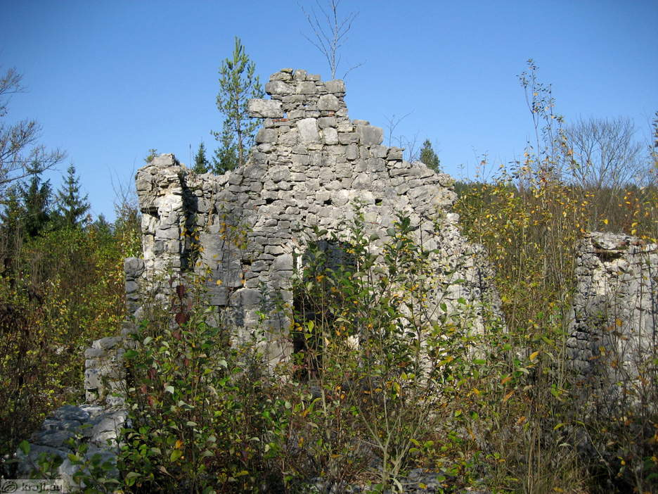

DAMIEN
(off)
I waken from horror. Every nerve is numb, every
muscle frozen, every bone an ache, my blood
throbbing with poison.

There follow ghoulish wailings...
DAMIEN
(off)
The mystery, the evil darkness of these incoherent
cries, sets my teeth on edge with horror.

31. MEDIUM VIEW

Suddenly, DAMIEN is fully awaken by CAPTAIN'S violent kick...

CONTINUED:

14.

CAPTAIN
Get up you bastard ! Is this how you keep guard ?!
Next time its the court-martial for you ! This is my
last warning !

32. CLOSE VIEW

DAMIEN
(off)
Their impotent malice so exceeds itself that I am
moved for a moment to laugh.

7.EXT – A FOREST PASTURE – MORNING

33. FULL VIEW

The column of SOLDIERS, led by the CAPTAIN on the white horse, entwines through the forest like a snake...Music: Genesis: »One for the Vine«(from the album »Wind and Wuthering«)...

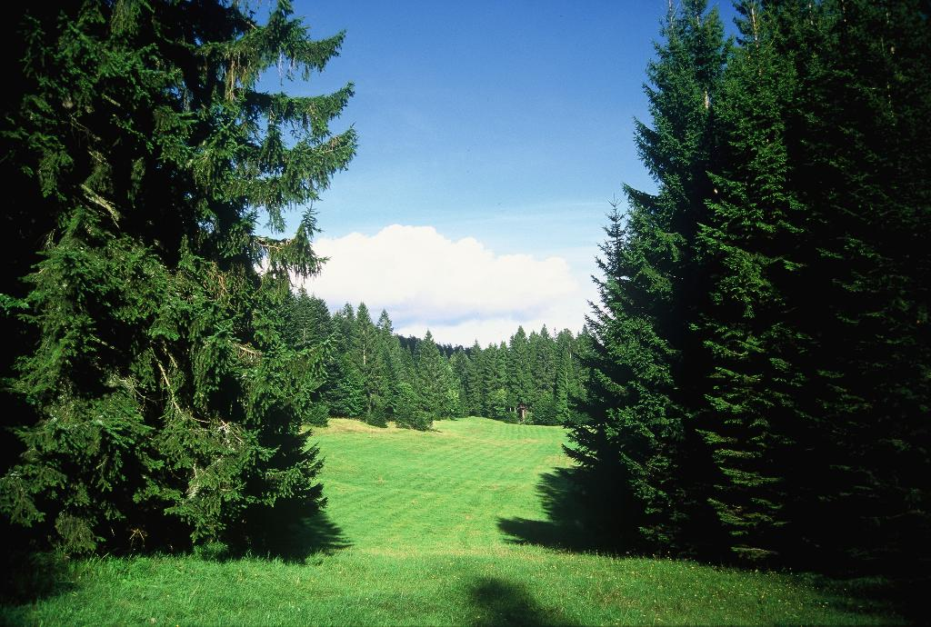

GENESIS
(off)
Fifty thousand men were sent, to do the will of one.

CONTINUED:

15.

34. MEDIUM VIEW, DOLLY SHOT DOWNWARDS AND PAN SHOT LEFT

CAPTAIN in the front, turns on the horse's back, and looks at the SOLDIERS, the unsatisfied faces of his men...
GENESIS
(off)
His claim was phrased quite simply, though he never
voiced it loud, I am he, the chosen one...

8.EXT – A MOUNTAIN VILLAGE – DAY

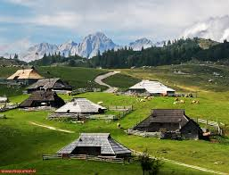

35. FULL VIEW

Under CAPTAIN'S command, the SOLDIERS attack a village, killing MEN and raping WOMEN, some of them dieing for the »cause«.

GENESIS
(off)
In his name they could slaughter, for his name they
could die.

36. MEDIUM VIEW

The clumsy SOLDIER NO.1 is having problems penetrating a VILLAGER WOMAN. She manages to reach for a jug and breaks it on his head.

GENESIS
(off)
Though many there were believed in him, still more
were sure he lied,

37. AMERICAN

DAMIEN keeps to the rear and to himself, avoiding to fire the gun...

CONTINUED:
16.

GENESIS
(off)
But they'll fight the battle on...

38. CLOSE VIEW

And the CAPTAIN is watching him all the time...

9. EXT – A PLAIN - DAY

39. MEDIUM FULL VIEW, TRACKING SHOT BACKWARDS, FULL VIEW

Afterwards, DAMIEN, marching at the end of the column, turns to his companion ANDREW...

DAMIEN
Farewell...

ANTHONY
Farewell...

GENESIS
(off)
Then one whose faith had died fled back up the
mountainside, but before the top was made,
a misplaced footfall made him stray from the path
prepared for him...

DAMIEN flees up the hill, towards the woods, but as he reaches the top, he tumbles down to the other side. Then, he picks himself up, and runs onward...

40. AMERICAN

The CAPTAIN turns, notices DAMIEN'S escape, but does not react to it...

41. MEDIUM VIEW

DAMIEN stands on the top of the hill looking back at the CAPTAIN...

42.43. CLOSE VIEWS

DAMIEN. CAPTAIN. Their views meet...

10. EXT – A MOUNTAIN SLOPE – DAY

44. FULL VIEW

The deserter crosses the slope...

CONTINUED:
17.

GENESIS
(off)
...off of the mountain, on to a wilderness of ice...

MUSIC FADE OUT:

45. CLOSE VIEW

DAMIEN sees a vision –
DAMIEN
(off)
Behind me – strange ! – the gloom is less obscure
than in the East to which the eyes yearn feebly.
Do I feel it by instinct – the form of a vast pyramidal
hill of stark black rock ?

46. MEDIUM (FULL) VIEW

a FIGURE, silhouette of a MAN dressed in black standing upon the mountain top, with the Sun shining behind him...

DAMIEN
(off)
All of a sudden, far behind me, far beyond that crest,
if it be one, rings out a voice,

47. AMERICAN IN THE FOREGROUND, FULL VIEW IN THE BACKGROUND

DAMIEN slowly ascends the mountain towards the FIGURE standing on the mountaintop...
Before him – the crest of the mountain and the shadow of the mysterious FIGURE...

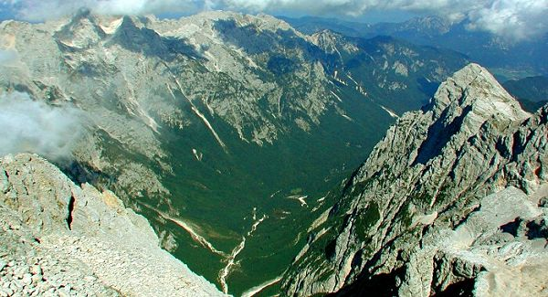

CONTINUED:
18.
DAMIEN
(off)
Clear, firm, courageous, confident.

48. CLOSE VIEW (IN THE FOREGROUND-THE FIGURE'S P.O.V.), FULL VIEW IN THE BACKGROUND

Upon the hilltop, a black FIGURE of a MAN is standing erect and shouting something, a message that echoes among mountain-tops...

DAMIEN
(off)
It is a soldier's voice, the accent of command,
the valour of manhood. None can mistake –
I am assured – that ringing call. Truth, Victory,
in each trumpet tone ! Listen !

49. MEDIUM VIEW (IN THE FOREGROUND), MEDIUM FULL VIEW (IN THE BACKGROUND)

He moves forward, towards the FIGURE OF MAN...

DAMIEN
(off)
And now I face Him as He stands above me.

Higher and higher he ascends the crest...

50. CLOSE VIEW

The silhouette of the MAN is backed by rays of clear sunlight, but the features of his face can now be discerned.

51. CLOSE UP

DAMIEN realises that the FIGURE is the FIGURE of HIMSELF.

DAMIEN
(off)
I understand that He – whoever, whatever He may
be – is He for whom we all so long had waited.

CONTINUED:

19.

11.EXT – UPON THE GREAT MOUNTAIN – SUNSET

52. MEDIUM FULL VIEW

DAMIEN ascends towards a mountain inn...He reaches a many-breached mountain sign.

53. CLOSE VIEW

The signs says: Transilvania 500 km, New York 3000 km, Vatican 400 km.etc...

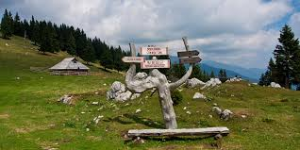

12. EXT - THE INN AT TRIGLAV LAKES, TRIGLAV NATIONAL PARK - SUNSET

54. MEDIUM FULL VIEW

DAMIEN arrives at the inn set up by the beautiful lakes...

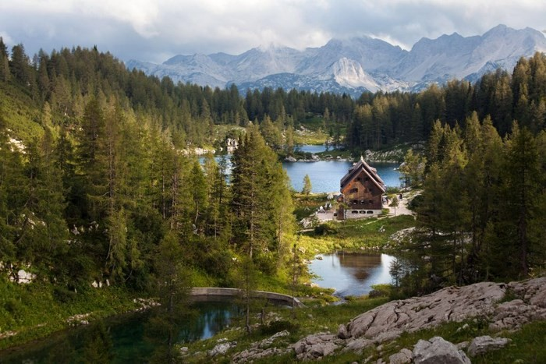

CONTINUED:

2O.

MUSICAL FADE IN:

GENESIS
(off)
This unexpected vision made him stand and
shake with fear,

13. INT – THE INN (VIBA FILM STUDIO) – »SUNSET«

55. MEDIUM (FULL) VIEW

He enters the inn, filled with layers of cigarette smoke. The VILLAGERS are drinking and laughing, but when they see DAMIEN they stop short.

56. AMERICAN, PAN SHOT LEFT

A beautiful WAITRESS avoids a caress by one of the VILLAGERS, hits him on the hand and gives DAMIEN a promising look.

GENESIS
(off)
But nothing was my fright compared with those
who saw him appear. Terror filled their minds
with awe...

MUSIC FADE OUT:

DAMIEN sits down at one of the tables, and the scarlet WAITRESS brings him a hot meal whic was primarily ordered by someone else. There is a strong chemistry between them...



He thanks her with a warm smile, and pays for the meal with a couple of coins.

57. MEDIUM VIEW

At the next table, DAMIEN notices a BIG HILLBILLY, who overthrows hands in contests with other VILLAGERS with great ease. The more the HILLBILLY drinks glasses of brandy, the easier he overthrows his opponents.
CONTINUED:

21.

Some VILLAGERS begin betting on DAMIEN and place money in a hat, then try to pull him to the next table for the contest.

58. MEDIUM CLOSE VIEW, TRACKING SHOT BACKWARDS

At the end DAMIEN agrees to do it, and sits opposed to the BIG HILLBILLY.
They try the might of their right arms, with a burning candle on each side, so that the looser gets his hand burned. After a long, intense struggle, full of overturns, DAMIEN manages to drop his opponent's arm.

59. MEDIUM VIEW

Followed by a loud »Hurrah!« of the VILLAGERS who placed their bets on DAMIEN, they lift him up and carry him out of the inn…

GENESIS
(off)
Simple were the folk who lived upon this frozen
Wave. So not surprising was their thought, This is
He, God's chosen one, who's come to save us from
All our oppressors. We shall be kings of this world.

14.EXT – THE VILLAGE ON THE GREAT MOUNTAIN – MORNING

60. MEDIUM FULL VIEW

The VILLAGERS carry him through the village, as if he were the Messiah, and throw flowers at him.

GENESIS
(off)
Follow me ! I'll play the game you want me, until
I find a way back home. Follow me ! I give you
strength inside you, Courage to win your battles –

61. MEDIUM VIEW, PAN SHOT RIGHT

MEN, WOMEN and CHILDREN place their new leader upon a white horse. The MEN, armed with guns, dung-forks, axes and other weapons group behind DAMIEN and, before they leave, the young WAITRESS kisses him goodbye...

DAMIEN
(off)
No, no, no, this can't go on, this will be all that
I fled from. Let me rest for a while...

CONTINUED:

22.

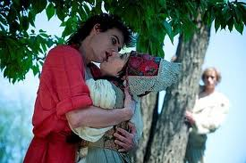

62. MEDIUM CLOSE VIEW

They kiss and part like the lovers of last night...

MUSICAL FADE OUT:

15.EXT – A RIDGE – DAY

63. FULL VIEW

The REBEL FORCES, now led by DAMIEN riding a white horse, move across the horizon...
They move upon the spine of a ridge, a long column of SOLDIERS...

64. MEDIUM VIEW, DOLLY SHOT DOWNWARDS AND PAN SHOT LEFT

DAMIEN in the front, turns on the horse's back, and looks at the rebels, the unsatisfied faces of his men...

16.EXT – THE RUINS OF STONE CASTLE, BEGUNJE – DAY

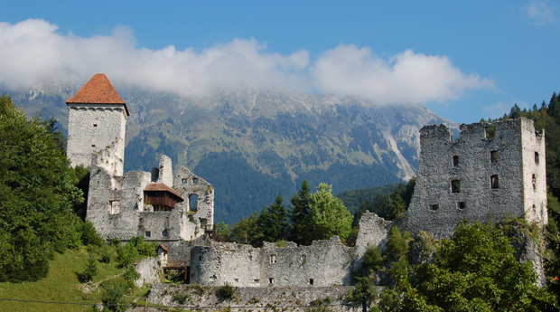
23.
65. FULL VIEW, TRACKING SHOT FORWARDS

The battalion crosses a mountain range, and they see the ruins of Stone castle in the green valley before them...

66. MEDIUM FULL VIEW, PARALLEL TRACKING SHOT

Above the ruins flickers the imperial military flag, and the SOLDIERS are spread out or grouped into »machine-gun nests« on various positions in the castle.
The GUARD notices the approaching REBELS, starts an alarm and suddenly there is a commotion in the castle, SOLDIERS running to their posts. Shooting begins on both sides...

67. HIGH FULL VIEW

Led by DAMIEN ,the REBELS approach the castle shooting and take tactical positions.

68. MEDIUM VIEW, SLOW MOTION

Then DAMIEN throws a hand-granade and leads the REBEL forces into the midst of the battle...

69. AMERICAN, SLOW MOTION

A series of sharp and powerful machine-gun shots forces DAMIEN to find shelter behind the protective wall.

It is then that DAMIEN suddenly realizes the truth, and withdraws from the battle...

CONTINUED:

24. 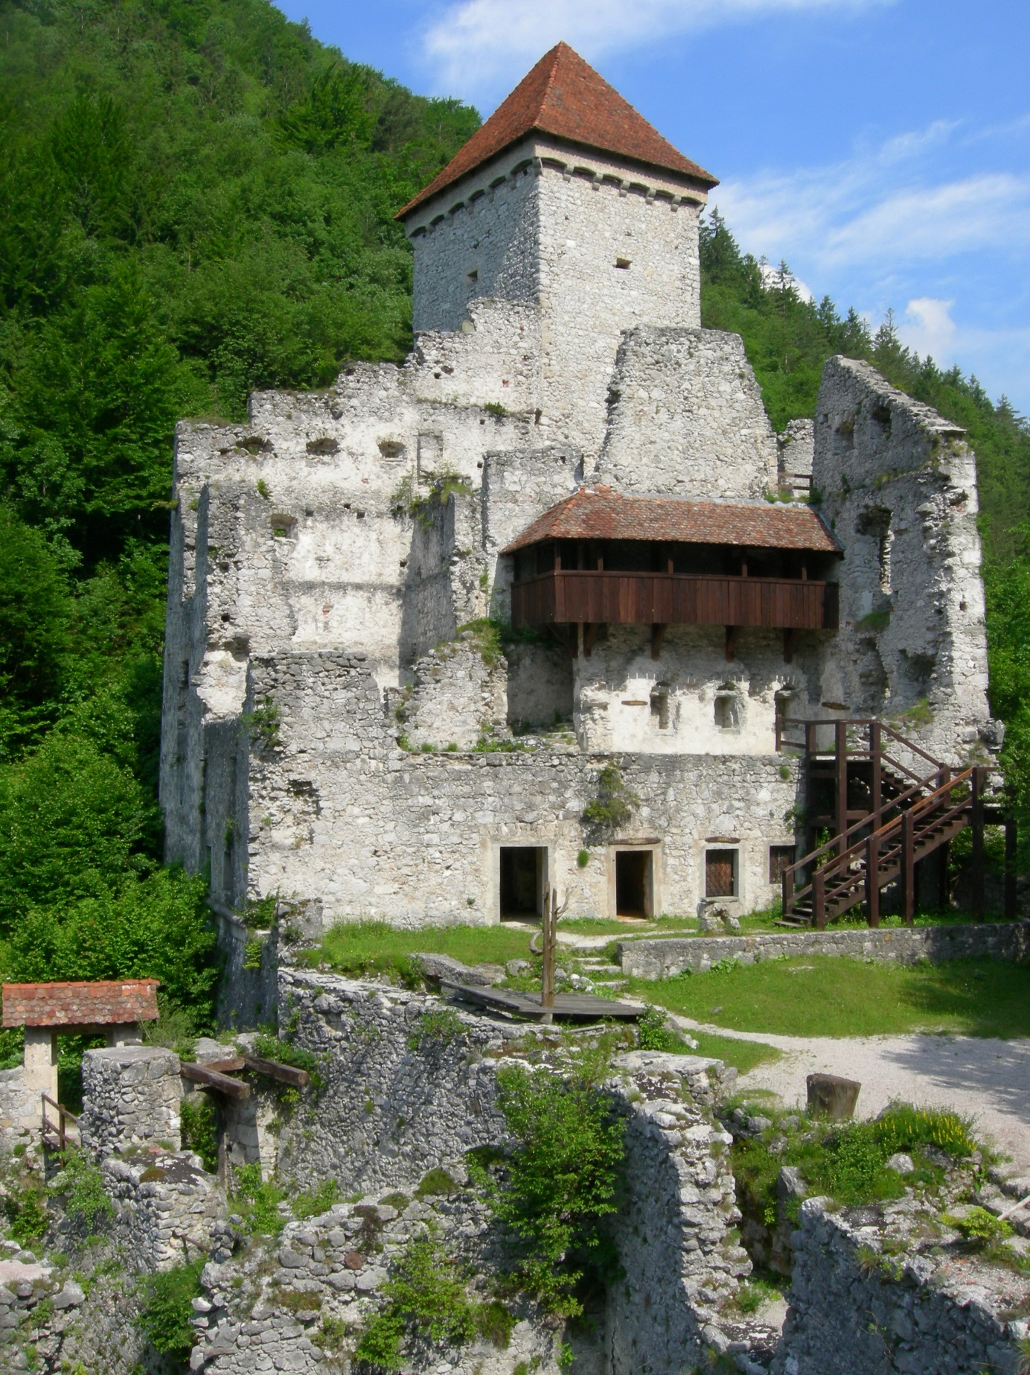

25.
17.EXT – THE ŠKOCJAN CANYON – DAY

70. MEDIUM FULL VIEW

MUSICAL FADE IN:

DAMIEN walks alone into a canyon through which a stream flows, cascading in smaller waterfalls...

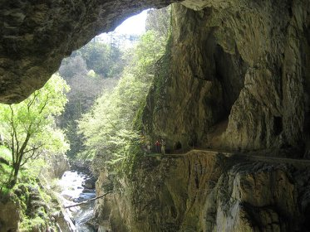

GENESIS
(off)
He walked into a valley, all alone. There he talked
with water and then with the vine.

71. FULL VIEW

He walks through a fantastic canyon...

72. MEDIUM VIEW

Then he sits by the on a stone by the water, has a drink of vine which he takes out of the saddle-bag and lights a cigarette, meditating...

CONTINUED:
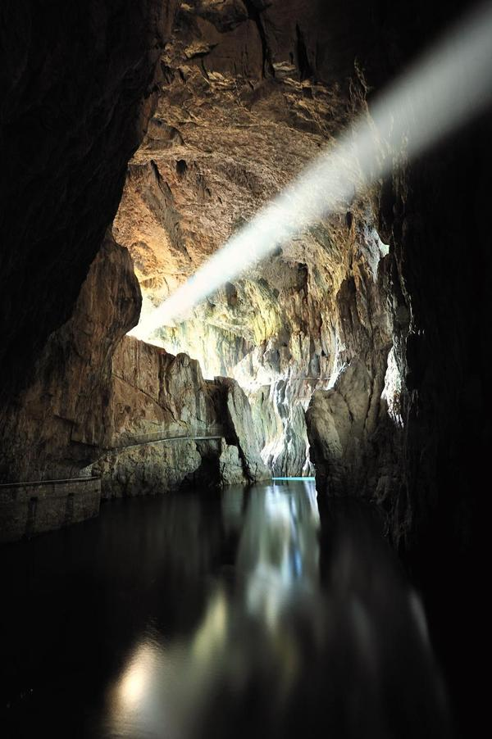

27.

18.EXT – THE REMAINS OF STONE CASTLE, BEGUNJE - DAY

73. FULL VIEW

The battle becomes furious in its intensity. Both sides are shooting...

19. EXT – THE ŠKOCJAN CANYON – DAY

74. CLOSE VIEW

In the canyon, DAMIEN decides and rises to go back...

GENESIS
(off)
They leave me no choice. I must lead them to glory
or most likely to death...

20. EXT – THE REMAINS OF THE STONE CASTLE, BEGUNJE

75. MEDIUM FULL VIEW

DAMIEN finds the REBEL forces fave won the battle and taken over the castle. Many SOLDIER'S bodies lie around, but DAMIEN shoots the CAPTAIN.

76. MEDIUM VIEW

ANTHONY is one of the prisoners, and DAMIEN greets him with a hug...

76. CLOSE VIEW

The rebel flag now takes over the flag-post.

21.EXT – A PLAIN – SUNSET

77. MEDIUM VIEW, DOLLY SHOT DOWNWARDS AND PAN SHOT LEFT, MEDIUM FULL VIEW

DAMIEN, now the leader af an ARMY, rides his horse in front of a column of REBELS and SOLDIERS who are either prisoners or have joined up the REBELS. ANTHONY is at the end of the column.

GENESIS
(off)
They travelled cross the plateau of ice, up to its
edge. Then they crossed a mountain range and
saw the final plain. Still he urged the people on...

But when he looks back, he sees a figure of a man from the end of the column departing and running away...

CONTINUED:
30.

GENESIS
(off)
Then, on a distant slope, he observed one without
hope flee back up the mountainside.

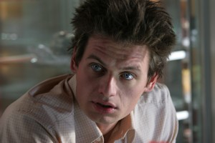

31.
78. MEDIUM VIEW

The FIGURE of the MAN stands upon the hilltop, looks back and their glances meet for a moment.

GENESIS
(off)
He thought he recognised him by his walk, and
by the way he fell, and by the way he stood up,
and vanished into air...

79. CLOSE VIEW

DAMIEN recognizes

80. CLOSE-UP

his friend ANTHONY.

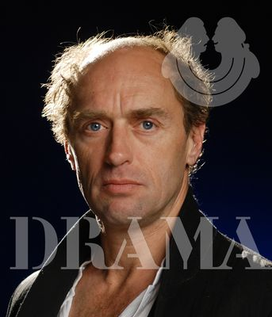

81. MEDIUM FULL VIEW, DOLLY CRANE UPWARDS

Then, ANTHONY disappears behind the crest's edge...

FADE OUT:

THE END

-AT THE END OF THE WORLD-

CONCEPT: This is a screenplay for a short anti-war film (Writers Guild of America Registration
No. 1481763), based on Genesis song »One For the Vine« by Tony Banks & strengthened by Aleister Crowley's essey »The Heart of the Master«, to be shot on Slovenia's most attractive locations by the graduate of Slovenia's film and television Academy AGRFT, Nikola Vrbavac.

Production Companies: Beast productions,

Producers:

Writer: Nikola Vrbavac, based on Genesis Tony Banks' lyrics »One for the Vine« &
Aleister Crowley's »The Heart of the Master«

Genre: (Anti)War/Action/Romance

Estimated Budget: $ 150.000

Status: Prepared to make offers to possible producers/distributors.

LOG LINE

Damien becomes a deserter from an unknown tyrannical army, only to become a leader of rebels himself, until the same kind of desertion happens to himself by his best friend. Thus, the circle of destiny is completed.

PITCH

»Platoon« meets »A Farewell to Arms«

TAGLINES:

All, or nigh all, seem fallen into heaviness, not from exhaustion of labour, but from lethargy.

But among us the sudden stirring warns me that not all were sleeping; that there were watchers like myself, men more intent than I.

The Zero Hour. Zero is Two.

- AT THE END OF THE WORLD –

TALENT:
SCREENPLAY BY, DIRECTED BY, EDITING: Nikola Vrbavac
DIREKTOR OF PHOTOGRAPHY:
PRODUCED BY:
MUSIC: Tchaikovsky 1-st Piano concerto,
Popol Vuh: »Ah!«,»Kyrie«,«Hosianna
Mantra«; Charles Gounod:«Sanctus«
2ND UNIT DIRECTOR: Marko Naberšnik
ASSISTANT DIRECTOR : Jure Žikić
MILITARY EXPERT: Ladislav Troha
SOUND MASTER: Hanna Preuss, (Jože Trtnik)
EDITOR: Andrija Zafranović
EXECUTIVE PRODUCER: Frenk Celarc
3rd ASSISTANT DIRECTOR(AGRFT):
PRODUCTION DESIGNER: Mojca Vilhar(TV),(Duško Milavec)(Frenk Kveder)
ORGANIZER OF SHOOTING:
MAKE-UP ARTIST: Alenka Nahtigal
CHIEF LIGHTING TECHNICIAN: Drago Jarič(?)
MIKROMAN:
COSTUME DESIGNER: Alan Hranitelj, (Bjanka Ursulov(?)
DOLLY GRIP:
ARMOURER & PYROTECHNIC: Jernej Brajer
ANIMAL TRAINER:
ASSISTANT EDITOR:
PROPERTY MASTER:
SPECIAL EFFECTS COORDINATOR:
STUNT COORDINATOR: Rok Cvetkov

CAST:
DAMIEN: Primož Bezjak
ANTHONY: Janez Škof
CAPTAIN: Igor Samobor
WAITRESS: Maja Martina Merjak (Tanja Žagar)
SOLDIER GREGOR: Gregor Bakovič
2nd SOLDIER: Zoran More
3rd SOLDIER: Vojko Zidar
THE SILHUETTE-FIGURE: Matjaž Tribušon
RAPED FARMWOMAN: Nina Ivanič
SHARPSHOOTER: Rok Cvetkov (stuntman)
HILLBILLY: Miloš Batellino
SOLDIERS & REBELS: Omar Naber, Nikola Kojo
and
SOLDIERS, REBELS and VILLAGERS: Extras

